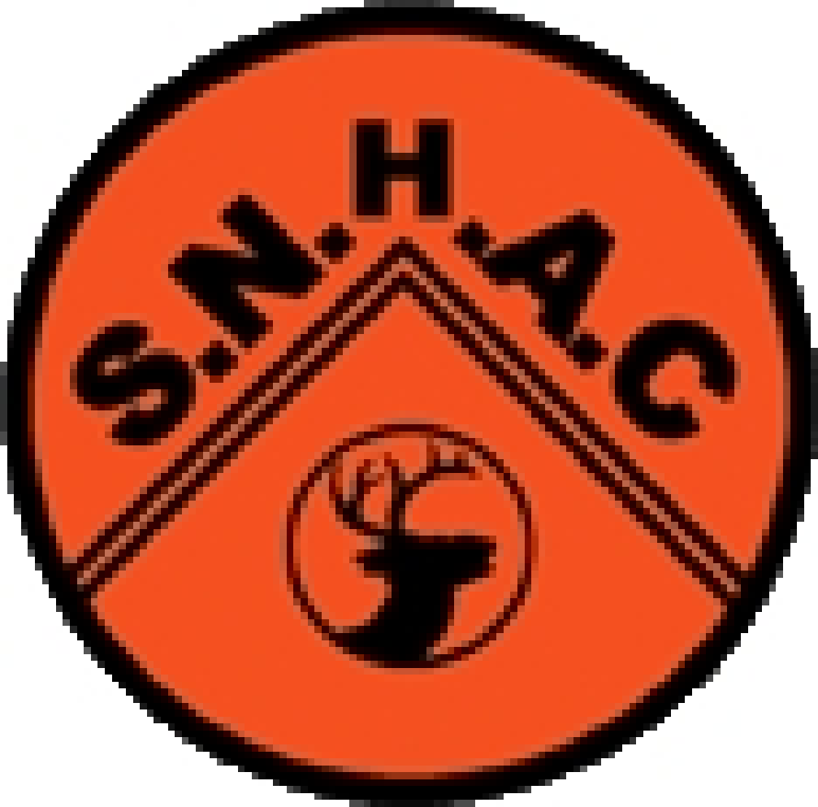
STEVENAGE AND NORTH HERTS ATHLETICS CLUB CHAMPIONSHIP

ENTRY FORM FOR 18TH September 2021

Please complete all of this form in BLOCK CAPITALS

SURNAME .................................….… FORENAME(S) .............................……….......

ADDRESS .................................…………………………………………………………………….

….................................……………………………………………….…………….……

Post code .............…. Tel.no .............................. e mail.........................…………………..

Date of Birth …………………………….

Please enter 3 events of your choice – performances will be allocated points from the performance tables and the highest point score will win each age group. Check timetable for clashes before entering.

event best performance age group man/woman/boy/girl Disability
Classification
.......................... ...................... ............…. .................... if appropriate

.......................... ...................... ………………

.......................... ......................

I declare that I am an amateur qualified to compete under the laws of UKAthletics

SIGNATURE ........................................ DATE ...................... ENTRY FEE ENCLOSED £............
do not send coins by post

Late entries will not be accepted CLOSING DATE Monday 13th September

BACS only payable to Stevenage and North Herts Athletic Club, account number 60201103, Sort code 20-41-12
Reference Club Champs plus athlete’s name

The timetable IS AVAILABLE on the notice board and the track and SNHAC Facebook page and website.
Please ensure events entered don’t clash.

Entries to Norma Harris by email or at the track
Or
Norma Harris, The Hideaway, 8 Hitchin Road, Shefford, Bedfordshire, SG17 5JA
Queries normajharris@hotmail.co.uk

Entry Fee £6 for 3 events

