Stevenage and North Herts Athletics Club Privacy Statement
Name of member: __________________________
How information about you will be used
SNHAC will use your information to provide you with information about the activities of the club. We only pass your information on to a third party in the circumstances listed below.
If you need any further information, please write to us: Mrs N. J. Harris, The Hideaway, 8 Hitchin Road, Shefford, Bedfordshire, SG17 5JA Secretary SNHAC
Your declaration
I understand the following:
- SNHAC will use the information I have provided to engage with me regarding a children for whom I have parental responsibility, concerning their engagement with Stevenage and North Herts AC.
- When you become a member of or renew your membership with SNHAC you will automatically be registered as a member of England Athletics (Excluding Years 4 & 5). SNHAC will provide England Athletics with your personal data which they will use to enable access to an online portal for you (called MyAthletics). England Athletics will contact you to invite you to sign into and update your MyAthletics portal (which, amongst other things, allows you to set and amend your privacy settings). If you have any questions about the continuing privacy of your personal data when it is shared with England Athletics, please contact dataprotection@englandathletics.org
- SNHAC will share certain data with league and competition organisers as well as the Hertfordshire County Athletics Association such as name, date of birth, email contact and EA affiliation number where this is required under league rules or for the purposes of team selection.
- SNHAC will not share your information with any other third-party organisation not mentioned above, other than in a Safeguarding or medical emergency.
- This agreement will remain in place for the children for whom I have parental responsibility, for the duration of their regular involvement in Stevenage and North Herts AC. and for four calendar years after.

I declare that the information I have given on this form is correct and complete.

Parent/Guardian/Carer Signature: |  | Date:

The Information Commissioner’s Office is the regulatory authority. If you are unhappy about how your data is being kept/used, you have the right to make a complaint to them directly.

SNHAC is sponsored by A1 German Car & Bike Specialists
Independent BMW, Mercedes, Audi, VW Service and Parts Centre in Stevenage
MOTs Servicing Repairs Diagnostics Wheel Repairs Brakes
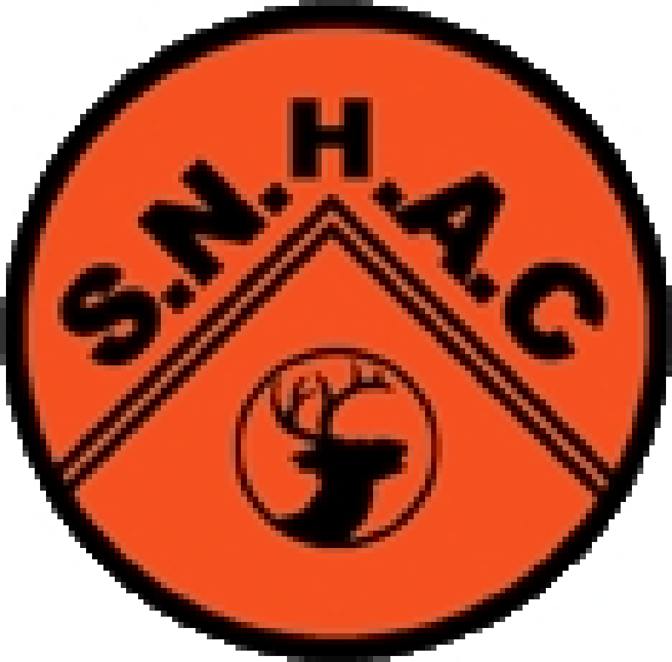
STEVENAGE AND NORTH HERTS ATHLETICS CLUB 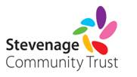
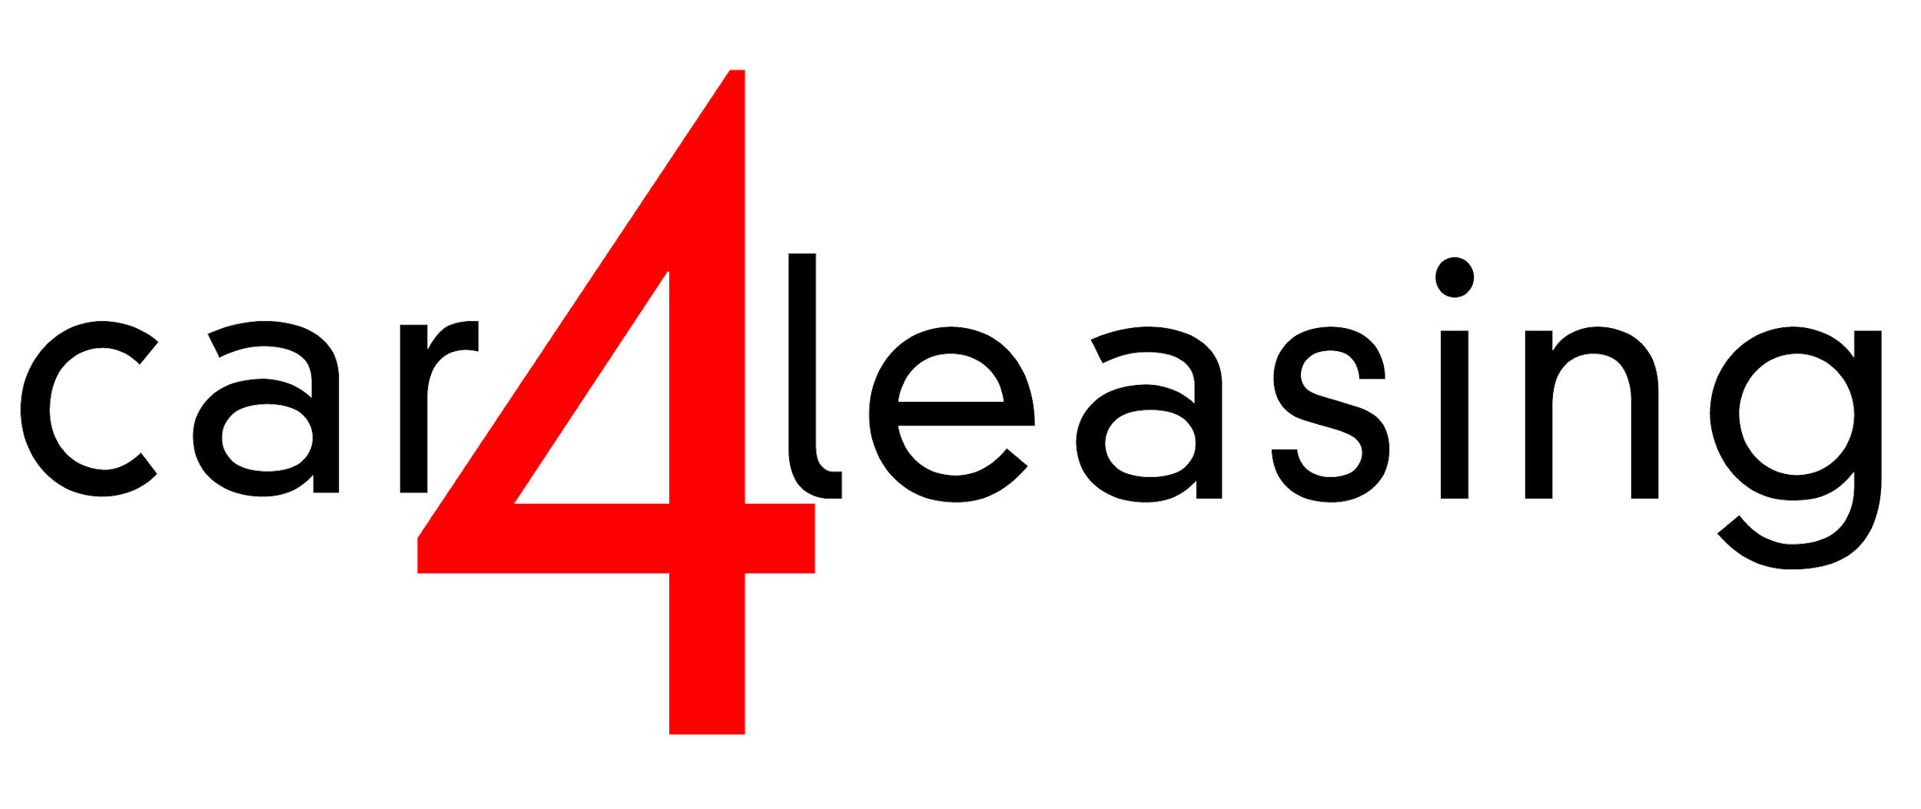
Affiliated to- England Athletics; Hertfordshire Association of Athletic & Running Clubs
2021 MEMBERSHIP APPLICATION (NEW MEMBERS ONLY)

SURNAME…..…………………….…..………...…..….…….. FIRST NAME……….….………..……....……. MALE / FEMALE
ADDRESS……..………………...…………………………………..………..………..TOWN…………..…...………….…...…….…
COUNTY…………..…….……………… P/CODE………………...….…….. PLACE OF BIRTH………………..….……….……
AGE……………....... DATE OF BIRTH …....../…...../….…..... SCHOOL……..…..……..………………………YEAR……....…
HOME TELEPHONE …………………………..…..……… MEMBER’S MOBILE………..………………………….……….……
E-MAIL ADDRESS.....................................................………….………………….………………….………....………………….
PERSONAL EMAIL and MOBILE (Parents if under 18) ………..…………………………….…………………...……………….
……………………………………………………………………………………………………………………………………………...
NAME OF ANY OTHER ATHLETICS CLUB ASSOCIATED WITH…………………………………………………………….…
ANY OTHER COMMENTS………………………………………………………………………………………………………..……

If the above named athlete has a medical condition (e.g. asthma), disability or support needs - Please list below:
Medical Conditions: ……………….……………..……………………………………………………......……………………..….. Disability YES / NO………..……………………………………………………………………………………………………………
Athletes under 18 Years of Age the Parents, Carers or Guardians must complete, sign and tick for them.
I Consent To: (tick as appropriate the below) (This must be completed or Membership will be Invalid) Tick
(1) First aid & medical treatment being given to the above named athlete, in the event of an emergency.◻
(2) Squad coaches, team managers and officials of SNHAC making direct contact with the above named athlete in
connection with training and competitions. ◻
(3) A club coach photographing/videoing the above named athlete in training and competitions for coaching purpose. ◻
(4) Photographic images of the above named athlete appearing on the Club’s website/social media, or being
used in conjunction with press reporting. ◻

Name of Parent, Carer or Guardian…………………….…………......………….. Signature…………………………………..
Emergency Contact numbers………………………….………………………………….……..………………………………..…
Athletes Signature (Over 18Yrs)………..…………………..,,,,,,,……………………….…….… Date………/….…/…………..

Annual Subscription due from January 1st (Includes England Athletics Affiliation fee where applicable) Tick
Adults and the first schoolchild (year 6 and upwards) in a family £ 50.00 per annum (includes affiliation/vest) ◻
Second and subsequent schoolchild (year 6 and upwards) in a family £ 40.00 per annum (includes affiliation/vest) ◻
Schoolchildren – Years 4 & 5 (affiliation not required) £ 20.00 per annum ◻
Second Claim £ 10.00 per annum ◻
Disability – Non Competing £15.00 per annum ◻

BACS only payable to Stevenage and North Herts Athletic Club, account number 60201103, Sort code 20-41-12
Please Note:- Membership Fees are not refundable.

