Core Stability
- Warm Up - Start by lying on your back with knees bent
- Your lumbar spine should be neither arched up nor flattened against the floor, but aligned normally with a small gap between the floor and your back. This is the "neutral" lumbar position you should learn to achieve
- Breathe in deeply and relax all your stomach muscles
- Breathe out and, as you do so, draw your lower abdomen inwards as if your belly button is going back towards the floor.
- Hold the contraction for 10 seconds and stay relaxed, allowing yourself to breathe in and out as you hold the tension in your lower stomach area
- Repeat 5-10 times
- Remember - Visualise the deep abdominal muscles as a corset that wraps round the abdomen
- Place one hand above the umbilicus (belly button) and one below
- Slowly draw in the lower abdomen, below the umbilicus, without drawing in the upper abdomen
- Hold the contraction whilst breathing normally
- Aim for a 10 second contraction, repeating it 10 times
- Do not let the whole stomach tense up or your upper abdominals bulge outwards, as this means you have cheated by using the large rectus abdominus muscle (the six-pack) instead of TA
- Do not brace your TA muscle too hard; just a gentle contraction is enough. Remember it's endurance not max strength your are trying to improve
- Do not tilt your pelvis nor flatten your back, as this means you have lost the neutral position you are trying to learn to stabilise
- Do not hold your breath, as this means you are not relaxed. You must learn to breathe normally and maintain the co-contraction of TA and MF
Repeat all of the below exercises x 3. Starting at 35 seconds per exercise and increasing by 5 seconds each week up to 1 minute per exercise. Always achieve the above position with the stomach muscles in each exercise. The core should continuously be contracted in this way for the duration of each exercise.

Plank
Hold a straight body position, supported on elbows and toes.  Brace the abdominals and maintain a straight body line through feet, hips and head. | 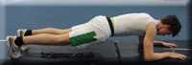

Side plank
Lie on one side, ensuring the top hip is above the bottom hip.  Push up until there is a straight body line through feet, hips and head.  Keep the elbow under the shoulder. Lower under control and repeat on opposite side. | 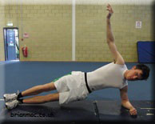

Bridge
Lie on the floor with your knees bent and feet flat on the floor.  Squeeze your gluteals and then push your hips up until there is a straight line through knee and hip to upper body and shoulders remain on the floor. | 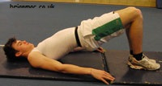

Superman
Kneel on the floor and place your hands below your shoulders and knees below your hips.  Extend right leg back and the left arm forward.  Maintain a straight body line through extended leg, body and extended arm. Repeat with opposite limbs | 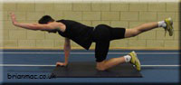

Side lying hip abduction
Lie on your side with your top hip above the lower hip.  Brace the abdominals and lift the top leg slowly up and down. | 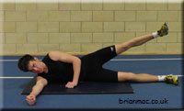

Oblique crunch
Lie on your back with your right ankle resting on your left knee.  Right arm is placed on the floor out to the side.  Keeping the right shoulder down, curl the left shoulder up to the right knee. Repeat with opposite limbs. | 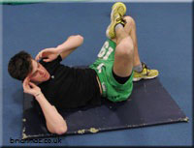

Straight leg raise
Lie on your back with knees bent. Brace your abdominals and lift your legs up straight in the air to an angle of 45 degrees keeping you back on the ground.  Keeping one leg in the air, slowly lower the other down to the floor. Only go as far as you can until you feel the lumbar spine start to move.  Keep bracing the abdominals and then lift the leg slowly back up. Repeat with the other leg. | 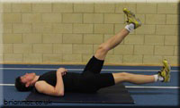

Lying windscreen wipers
Lie on your back with arms out to the sides. Lift your legs straight up in the air until the hips are at 90 degrees. Keeping your legs straight and maintaining the hip angle, rotate the legs to one side. Go as far as you can keeping your upper back and shoulders on the floor. Bring the legs to a halt, pull them back up to the start position and then over to the other side.
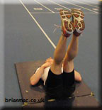 | 